

SIMATS ENGINEERING
Saveetha Institute of Medical and Technical Sciences
Chennai- 602105
Student Name: K.R.Lohithya | Reg. No.:192424154
Course Code: DSA0613 | Slot: Slot-A
Course Name: Data Handling Visualization for Data Analysis
Course Faculty: Dr. Kumaragurubaran, Dr. Senthilvadivu.S

Project Title: Social Media Impact Analysis Through Data Visualization
Module Photographs: (3 photographs –Module Photo, Individual student contribution module work in the project and presentation image)
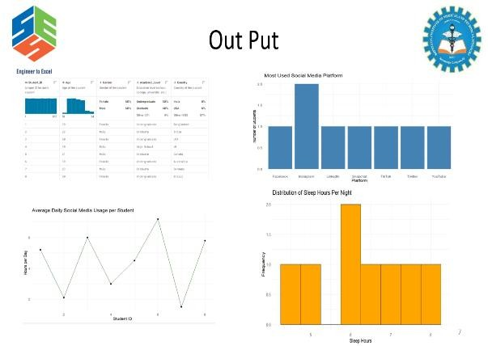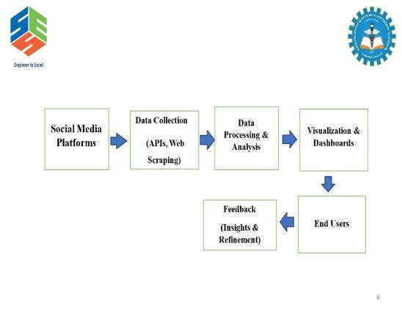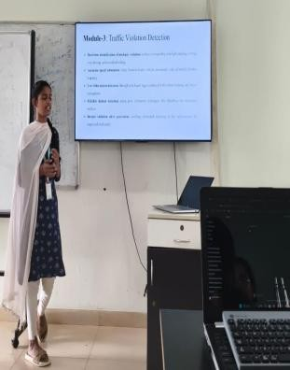

Project Description: (here you write what you did in this project (contribution) including Model
Description
Module 2: Relationship & Trend Analysis
This module examines the relationships between different social media variables such as posts, likes, comments, and shares. It helps identify how one factor influences another over time. Trend analysis reveals patterns of growth or decline in user engagement. Line graphs and scatter plots are commonly used to visualize these relationships clearly. By observing trends, we can predict future engagement behavior. Overall, this analysis supports strategic planning and performance improvement. To analyze the relationship between different engagement metrics and identify user behavior patterns. Relationship between likes, shares, and comments. Effect of posting time on engagement. These visual representations help identify engagement trends, peak activity periods, and content performance, making complex data easy to understand.

FORMULAS

∑𝒙𝒚
- Correlation: 𝒓⁼ _{𝟐∑𝒚𝟐}
√∑𝒙
𝚫𝒚
- Trend (Slope): 𝒎=
𝚫𝒙
∑𝒙
- Moving Average: 𝑴𝑨=
𝒏
𝒚
- Growth Rate: 𝑮𝑹= ^{𝟐−𝒚𝟏}
𝒚𝟏

Student Signature Guide Signature

